NAME | SIGNATURE
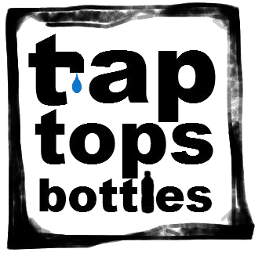
TAP TOPS BOTTLES PETITION
We are a group of international students who, in the context of our Social media and Global Change class want to spread the word that drinking tap water offers many advantages compared to bottled water! We want the administration of the Freie Universität to install water fountains on campus so that students can refill their water bottles! Drinking Tap water is as healthy as drinking bottled water and would help students save money and make an environmental impact.
So why not drink tap water? Sign our petition!

